**Tracing the growth of global community-A population forecasting analysis**

1.INTRODUCTION

1.1 overview

This method involves discovery of the factors that influence present and past population increase and decrease.

1.2purpose

Global communities delivers essential solution to complex challenges from the intersection of humanitarian assistance,sustainabke development and financial inclusion.

2.**problem definition & design thinking**

2.1 Empathy map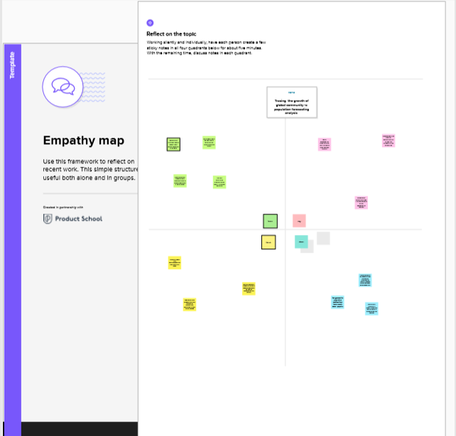

2.2 Ideation & Brainstorming Map

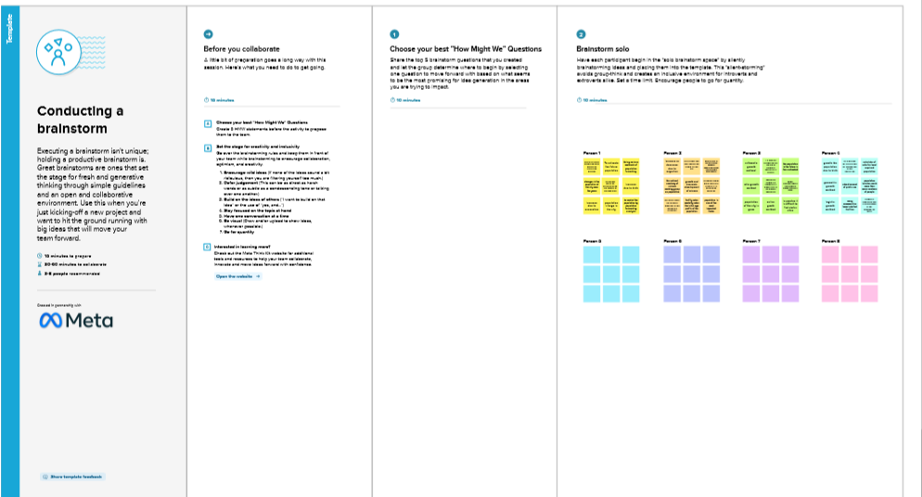

3.RESULT

The present report , Global population Growth and sustaiable Development , examines the linkages between global population growth and the social, economic and dimensions of sustainable development.

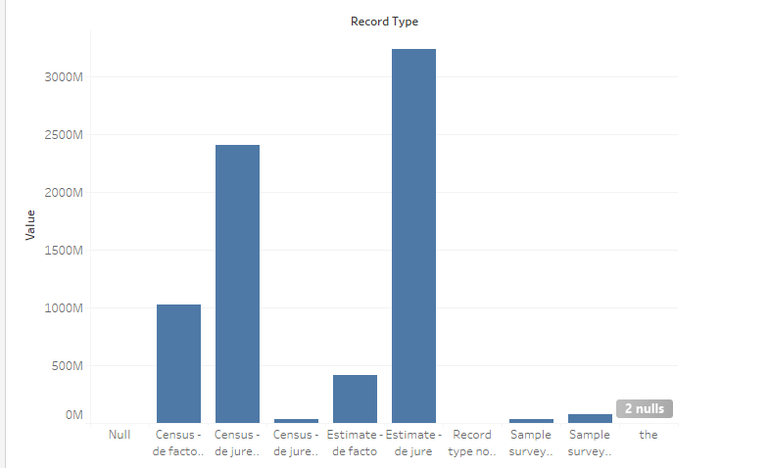

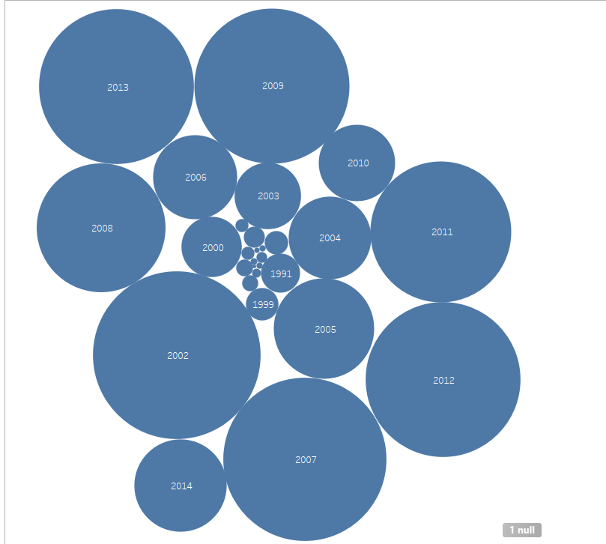

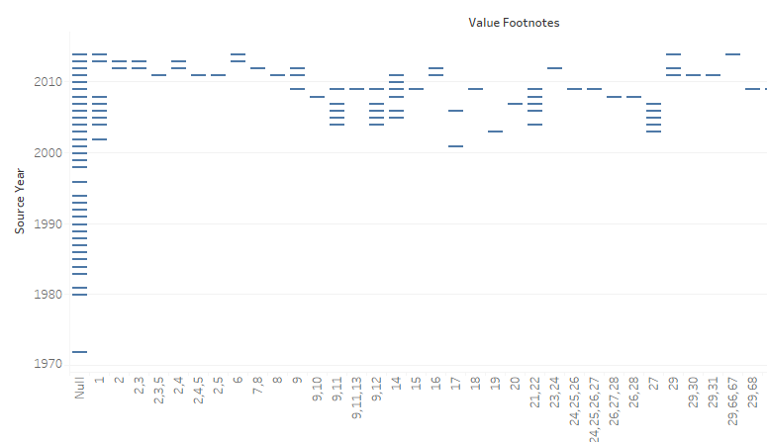

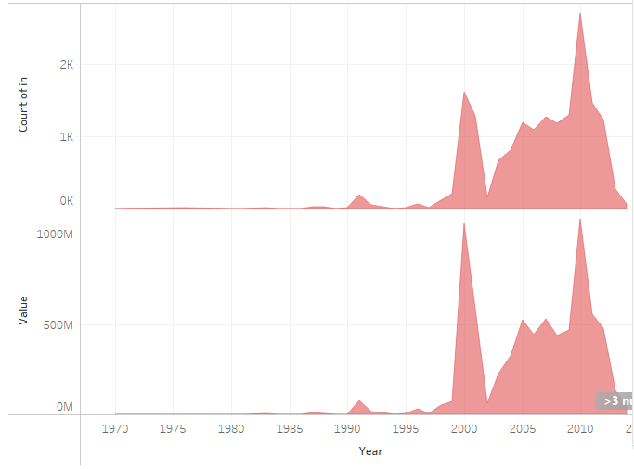

4.ADVANTAGES & DISADVANTAGES

* Reliable regional population forecasting can provide important for urban planning, especially for decision support in regional planning.

DISADVANTAGE

* The disadvantages pertaining to forecasting include the Forecasts are Never Complete Accurate-Forecasts are never 100% and it is almost impossible to predict the future with certainty.

5.APPLICATIONS

Population forecasting is a method to predict/forecast the future population of an area.

6.CONCLUSION

Therefore, we can conclude that the major growth of population in the world. It is very fun and exiciting to work.

7.Future scope

Forecasting refers to the practice of predicting what will happen in the future by taking into considering events in the past and present.